**ODE TO CODE  
Sprint 2 Project Documentation**

**For**

**HealthSync Patient Management System Version 1.0**



SUBMISSION DATE- 18 OCTOBER 2023

MR D BOUCHER

Declaration of Work:

We, Ode to Code, declare that:

* The system developed is our original work and has not in part been submitted for the purposes of final assessment for any other 3rd year project module,
* We have the permission to use images shown in our system and have created our own logos that are used in our system,
* Where we have made use of programming assistance, we acknowledge this fact in the acknowledgements section below,
* We did not outsource the building of the entire system to a third party.

About The Ode to Code team

Ode to Code is an organizational team founded by Tyson Jule, Olona Nene, Cwenga Mpompo, Langa Thandile and Sami Charity, a group of third year students with a common mission of ensuring healthy lives and promote well-being for all ages. The team has opted to design and create a patient management system, HealthSync patient management system, it will improve efficiency, accuracy, and patient satisfaction in the healthcare industry. This will help achieve their mission.

Group Members and their Roles:

|  |  |  |  |
| --- | --- | --- | --- |
| **Name and Surname** | **Student Number** | **Role(s)** | **Electronic Signature** |
| Olona Nene | 202016044 | PR, PM, BA | O. Nene |
| Tyson Jule | 202126242 | PR, DO, BA | T. Jule |
| Cwenga Mpompo | 202112803 | DO, PA, PR | C. Mpompo |
| Thandile Langa | 202123409 | BA, PR, DO | T. Langa |
| Charity Sami | 201906482 | BA, DO, PR | C. Sami |

***Role Key:***

PM: Project Manager *(only one member can be PM at any given time)*

BA: Business Analyst

DO: Documenter

PR: Programmer

*A team member can complete multiple roles.*

Acknowledgements:

We would like to thank:

1. Lecturers:
   * Mr. D. Boucher
   * Dr E. Chindenga
   * Mr. T. Breetzke

Our Mentor: Andisiwe Nomnyama

Table of Contents

SECTION A – Business Process Description 7

System Reference Matrix 7

Use Case Diagram 8

USE CASE NARRATIVES 9

USE CASE NARRATIVE 1 - Register 9

USE CASE NARRATIVE 2 - Login 11

USE CASE NARRATIVE 3 – Prescription Allocation 13

USE CASE NARRATIVE 4 - Schedule Appointment 15

USE CASE NARRATIVE 5 – Prescription Management 17

USE CASE NARRATIVE 6 – Payment 19

USE CASE NARRATIVE 7 – Manage Appointment 21

SECTION B: DATA MODELLING REQUIREMENTS 23

ENTITY RELATIONSHIP DIAGRAM 23

ATTRIBUTE FRAMING 24

SECTION C: SYSTEMS DESIGN REQUIREMENTS 28

UML WINDOW NAVIGATION DIAGRAM 28

WINDOW SCREEN FLOW DIAGRAM - PATIENT 29

29

WINDOW SCREEN FLOW DIAGRAM - HEALTHCARE PROVIDER 30

30

SR1: REGISTRATION PAGE 31

31

SR2: PAYMENT INTERFACE/ PROCESSING 33

SR3: LOGIN PAGE 34

SR4: PATIENT HOME PAGE FOR HEALTHCARE PROVIDERS. 35

SR5: PATIENTS MAKE AN APPOINTMENT 36

SR6: PRESCRIPTION. 37

SR7: MEDICINE 38

SR8: HOMEPAGE FOR HEALTHCARE PROVIDERS. 39

SR9: DOCTORS 40

SR10: MANAGE PRESCRIPTION. 41

SR11: MANAGE APPOINTMENTS 42

SR12: MANAGE PAYMENTS 43

SR13: REPORTS. 44

SR14: CONTACT US 45

LIST OF FIGURES

Figure 1: USE CASE DIAGRAM 8

Figure 2: ACTIVITY DIAGRAM FOR UCN1 10

Figure 3: ACTIVITY DIAGRAM FOR UCN2 12

Figure 4: ACTIVITY DIAGRAM FOR UCN3 14

Figure 5: ACTIVITY DIAGRAM FOR UCN4 16

Figure 6: ACTIVITY DIAGRAM FOR UCN5 18

Figure 7: ACTIVITY DIAGRAM FOR UCN6 20

Figure 8: ACTIVITY DIAGRAM FOR UCN7 22

Figure 9: ENTITY REATIONSHIP DIAGRAM 23

Figure 10: UML WINDOW 28

*Figure 11: WINDOW SCREEN FLOW DIAGRAM* 29

Figure 12: HEALTHCARE PROVIDER 30

Figure 13: REGISTRATION PAGE 31

Figure 14: PAYMENT INTERFACE/ PROCESSING 33

Figure 15: LOGIN PAGE 34

Figure 16: PATIENT HOME PAGE 35

Figure 17: APPOINTMENT SCHEDULING 36

Figure 18: PRESCRIBED MEDICINE 37

Figure 19: MEDICINE 38

Figure 20: HOMEPAGE FOR HEALTHCARE PROVIDER(S). 39

Figure 21: DOCTORS 40

Figure 22: PRESCRIPTION MANAGEMENT 41

Figure 23: APPOINTMENTS MANAGEMENT 42

Figure 24: PAYMENTS MANAGEMENT 43

Figure 25: REPORTS 44

Figure 26: CONTACT PAGE 45

LIST OF TABLES

Table 1: SYSTEM REFERENCE MATRIX 7

Table 2: UCN1 9

Table 3: UCN2 11

Table 4: UCN3 13

Table 5: UCN4 15

Table 6: UCN5 17

Table 7: UCN6 19

Table 8: UCN7 21

Table 9:Patients 24

Table 10: Healthcare Provider 24

Table 11: Appointment 25

Table 12: Prescription 26

Table 13: Payment 26

Table 14: Contact Us 27

Table 15: SR1: Registration page 32

Table 16: SR2: PAYMENT INTERFACE/ PROCESSING 33

Table 17: SR3: LOGIN PAGE 34

Table 18: SR4: PATIENT HOME PAGE FOR HEALTHCARE PROVIDERS 35

Table 19: APPOINTMENT SCHEDULING 36

Table 20: PRESCRIBED MEDICINE 37

Table 21: SR7: HOMEPAGE FOR HEALTHCARE PROVIDER(S). 39

Table 22: PRESCRIPTION MANAGEMENT 41

Table 23: APPOINTMENTS MANAGEMENT 42

Table 24: PAAYMENTS MANAGEMENT 43

Table 25: SR15: CONTACT PAGE 45

# SECTION A – Business Process Description

## System Reference Matrix

|  |  |  |  |  |  |
| --- | --- | --- | --- | --- | --- |
| **Business Process** | **Reference** | **Use Case** | **Tables** | **Screen** | **Report** |
| Registering patient | UC1 | Register | Patient | Registration – SR2 | Registered patients report |
| Login to the system | UC2 | Login | Patient,  Healthcare Provider | Login – SR1 | Successfully logged-in patients. |
| Schedule Appointment | UC3 | Schedule appointment | Patient | Scheduling  Appointment – SR4 | Appointment scheduled report |
| Pay for appointment | UC4 | Confirm Payment | Patient, Appointment | Payment – SR3 | Payment report |
| Allocate prescription | UC5 | Allocate prescription | Healthcare Provider | Allocate prescription1 – SR7 | Prescription report |

Table 1: SYSTEM REFERENCE MATRIX

## Use Case Diagram

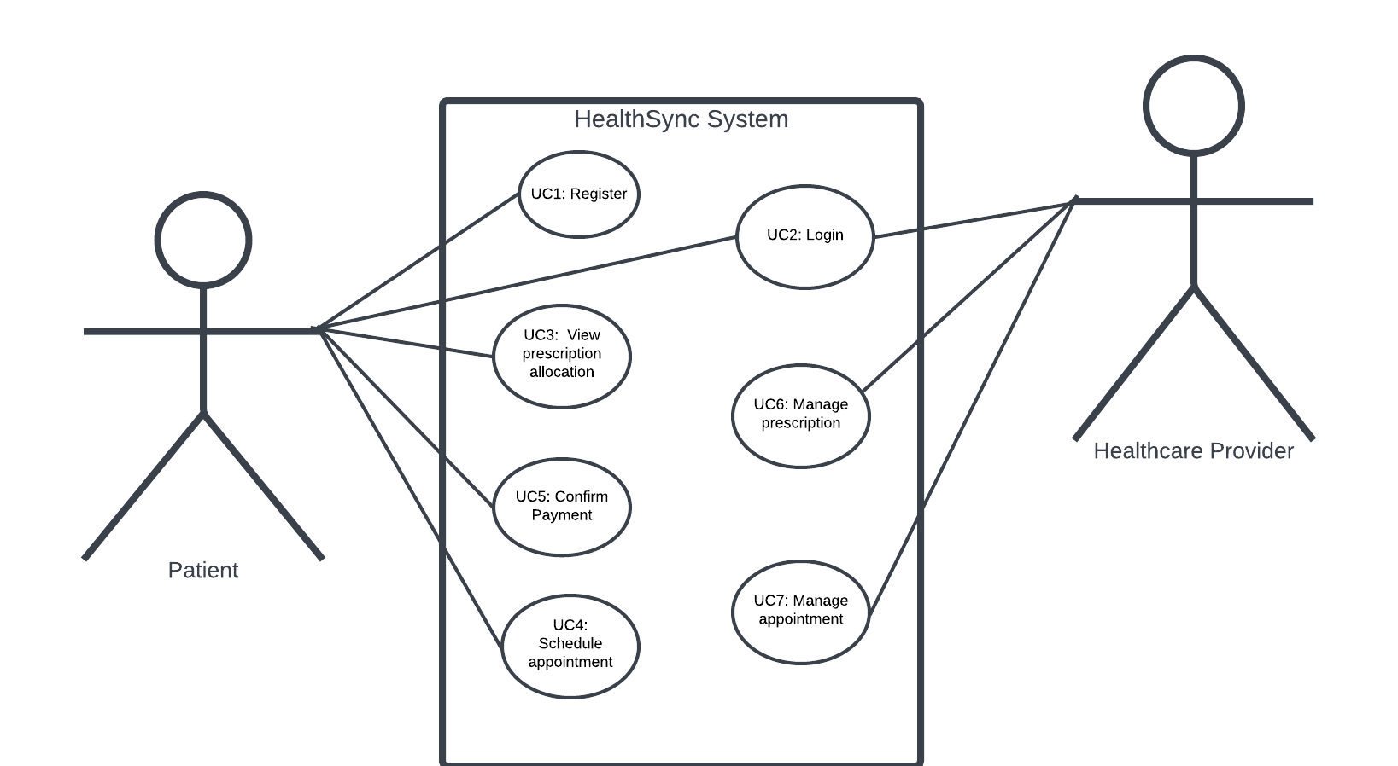

Figure 1: USE CASE DIAGRAM

## USE CASE NARRATIVES

### USE CASE NARRATIVE 1 - Register

|  |  |  |  |  |
| --- | --- | --- | --- | --- |
| **HealthSync System** | | | | |
| **Use Case Specification** | | | | |
| Use Case Id | UC1 | | | |
| User Case Name | Register | | | |
| Actor(s) | Patient | | | |
| Brief Description | Allows the patient to use the system and access the services. | | | |
| Frequency of use | As required | | | |
| Pre-conditions | The patient acknowledges the existence of the system. | | | |
| Main Flow of Events | Actor | | System | |
| 1. Click on register. 2. Enter registration information. 3. Submit the information by clicking on a register button. | | * 1. Display registration page.   2. Display registration information.   3. Save registration information. | |
| Alternative Flows of Events | At any point before a patient registering, the patient can return to the previous pages to change any wrong written details. | | | |
| Impact on database | [Patient] {C} | | | |
| Created by | Cwenga Mpompo | Approved by | | Tyson Jule |

Table 2: UCN1

#### ACTIVITY DIAGRAM FOR UCN1

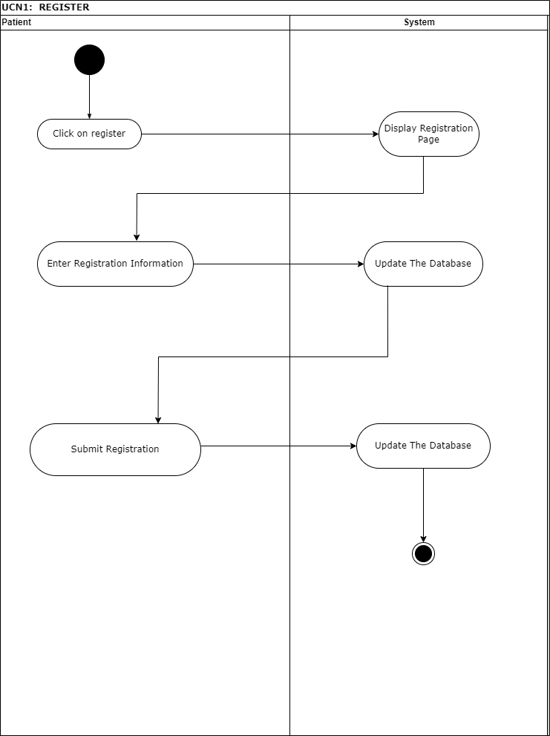

Figure 2: ACTIVITY DIAGRAM FOR UCN1

|  |  |  |  |  |
| --- | --- | --- | --- | --- |
| **HealthSync System** | | | | |
| **Use Case Specification** | | | | |
| Use Case Id | UC2 | | | |
| User Case Name | Login | | | |
| Actor(s) | Patient, Healthcare provider | | | |
| Brief Description | Each user provides login credentials to the system | | | |
| Frequency of use | As required | | | |
| Pre-conditions | When a user wants to log in, the database must be connected. | | | |
| Main Flow of Events | Actor | | System | |
| 1. Enter credentials. 2. Click login | | 2.1 Verify credentials.  2.2 Grant access. | |
| Alternative Flows of Events | 1. If the patient provides incorrect credentials, a pop error message will display, and access denied.  2. If the user tries to log in without registering first, they must click on sign up to gain access to the system. | | | |
| Post - Condition | Patients will have access to the system, but according to their roles in the system. | | | |
| Impact on database | [Patient] {R}, [ Healthcare provider] {R} | | | |
| Created by | Cwenga Mpompo | Approved by | | Tyson Jule |
| Date | 11/10/2023 | Date | | 16/10/2023 |

### USE CASE NARRATIVE 2 - Login

Table 3: UCN2

#### ACTIVITY DIAGRAM FOR UCN2

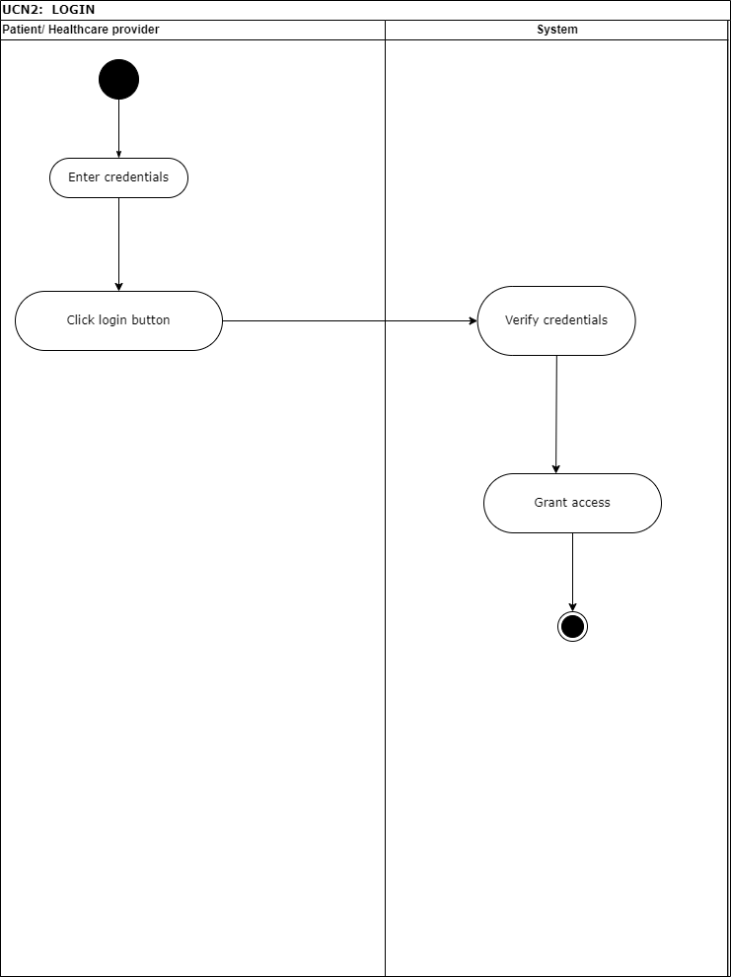

Figure 3: ACTIVITY DIAGRAM FOR UCN2

### USE CASE NARRATIVE 3 – Schedule Appointment

|  |  |  |  |  |
| --- | --- | --- | --- | --- |
| **HealthSync System** | | | | |
| **Use Case Specification** | | | | |
| Use Case Id | UC4 | | | |
| User Case Name | Schedule Appointment | | | |
| Actor(s) | Patient | | | |
| Brief Description | Allow a patient to make an appointment with any available healthcare provider at that time. | | | |
| Frequency of use | As required | | | |
| Pre-conditions | Patients need to be registered and logged in to the system before they perform this action. | | | |
| Main Flow of Events | Actor | | System | |
| 1. Patients click on appointment scheduling. 2. Enter the information needed for appointment scheduling. 3. Click on submit. | | 1.1 Display the appointment scheduling page.   * 1. Save the appointment scheduling information.   3.1 Show a message saying appointment successfully booked.  3.2 Update the database. | |
| Alternative Flows of Events | At any point before a patient book an appointment need to login firstly. | | | |
| Impact on database | [Patient] {C; D and U}, | | | |
| Created by | Cwenga Mpompo | Approved by | | Tyson Jule |
| Date | 11/10/2023 | Date | | 16/10/2023 |

Table 4: UCN3

#### ACTIVITY DIAGRAM FOR UCN3

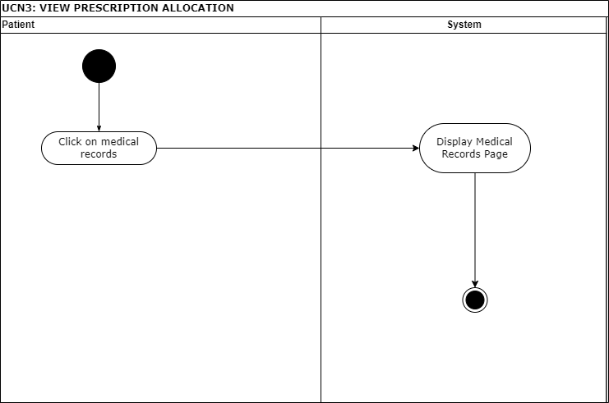

Figure 4: ACTIVITY DIAGRAM FOR UCN3

### USE CASE NARRATIVE 4 - Confirm Payment

|  |  |  |  |  |
| --- | --- | --- | --- | --- |
| **HealthSync System** | | | | |
| **Use Case Specification** | | | | |
| Use Case Id | UC6 | | | |
| User Case Name | Payment | | | |
| Actor(s) | Patient | | | |
| Brief Description | All patients use the system to see how to take their medication | | | |
| Frequency of use | As required | | | |
| Pre-conditions | Patients need to be registered and logged in to the system before they perform this action. | | | |
| Main Flow of Events | Actor | | System | |
| 1. Click payment. 2. Enter payment details. | | * 1. Display payment page   2.1 Process payment.  2.2 Confirm payment. | |
| Alternative Flows of Events | If the patient does not have sufficient funds, the payment will be declined and an insufficient fund notification will appear, requesting the patient to make another payment. | | | |
| Impact on database | [Patient] {R}, [Appointment] {R, U} | | | |
| Post-conditions | The system will confirm successful payment | | | |
| Created by | Cwenga Mpompo | Approved by | | Tyson Jule |
| Date | 11/10/2023 | Date | | 16/10/2023 |

Table 5: UCN4

#### ACTIVITY DIAGRAM FOR UCN4

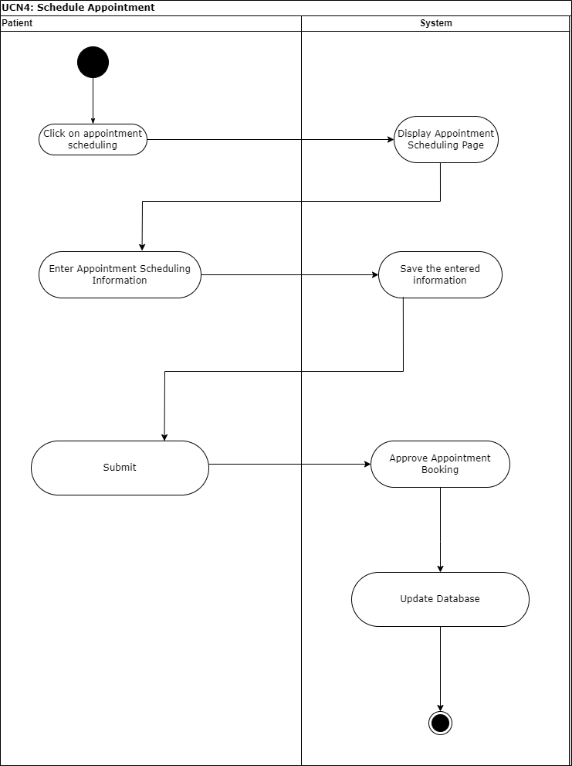

Figure 5: ACTIVITY DIAGRAM FOR UCN4

#### ACTIVITY DIAGRAM FOR UCN5

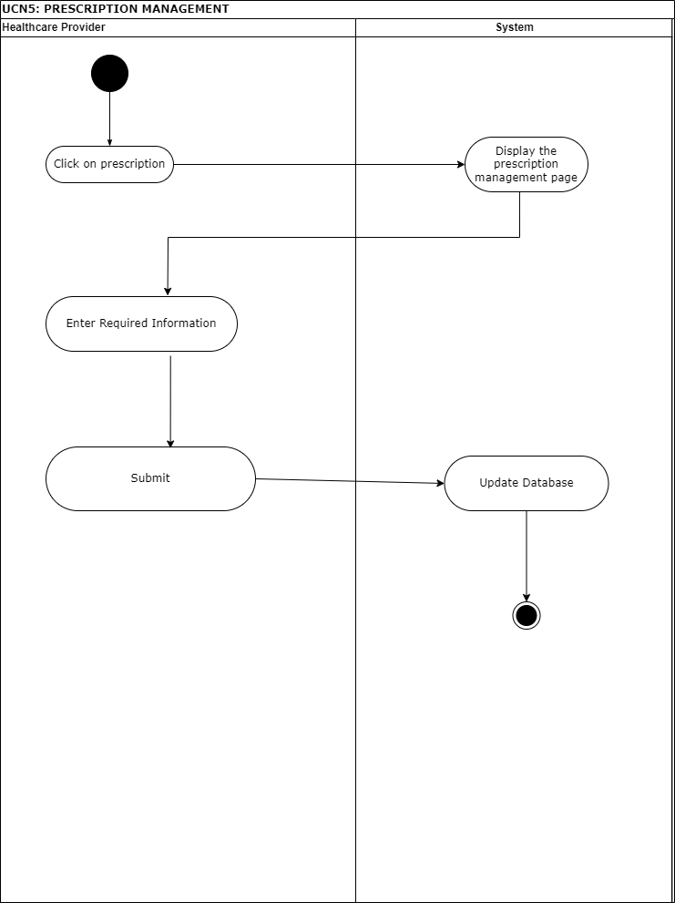

Figure 6: ACTIVITY DIAGRAM FOR UCN5

### USE CASE NARRATIVE 6 – Allocate Prescription

|  |  |  |  |  |
| --- | --- | --- | --- | --- |
| **HealthSync System** | | | | |
| **Use Case Specification** | | | | |
| Use Case Id | UC6 | | | |
| User Case Name | Allocate prescription | | | |
| Actor(s) | Patient | | | |
| Brief Description | The healthcare provider uses the system to allocate a prescription to a patient. | | | |
| Frequency of use | As required | | | |
| Pre-conditions | Patients need to be registered and logged in to the system before they perform this action. | | | |
| Main Flow of Events | Actor | | System | |
| 1. Click on allocate prescription. 2. Fill in the required information. 3. Click on the submit button. | | * 1. System shows the allocate prescription page.   3.1 Information is saved to the database. | |
| Alternative Flows of Events | If the patient deems the integrity of prescription allocated, the patient will make use of the contact page to leave a comment and admin, or doctor will be able to see that. | | | |
|  |  | | | |
| Created by | Cwenga Mpompo | Approved by | | Tyson Jule |
| Date | 11/10/2023 | Date | | 16/10/2023 |

Table 7: UCN6

#### ACTIVITY DIAGRAM FOR UCN6

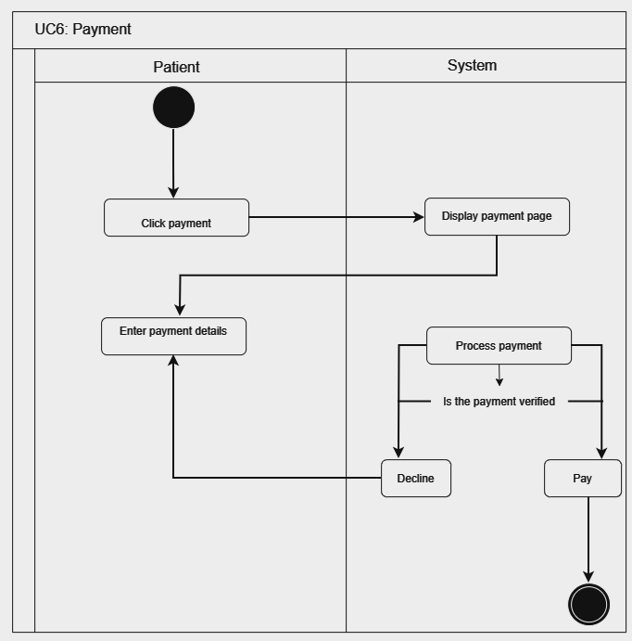

Figure 7: ACTIVITY DIAGRAM FOR UCN6

#### ACTIVITY DIAGRAM FOR UCN7

Figure 8: ACTIVITY DIAGRAM FOR UCN7

# SECTION B: DATA MODELLING REQUIREMENTS

## ENTITY RELATIONSHIP DIAGRAM

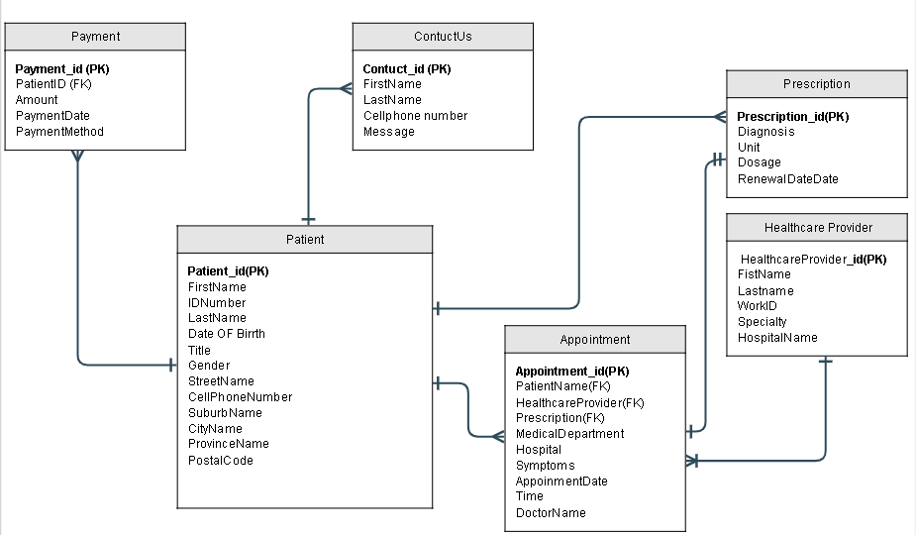

Figure 9: ENTITY REATIONSHIP DIAGRAM

## ATTRIBUTE FRAMING

|  |  |  |  |  |
| --- | --- | --- | --- | --- |
| Attribute Name | Description | Data Type | Key Status | Integrity Constraint |
| PatientID | Unique identifier of the patient | int | PRIMARY KEY | NOT NULL |
| First Name | Patient’s first name | varchar (50) |  | NOT NULL |
| Last Name | Patient’s surname | Varchar (50) |  | NOT NULL |
| ID Number | Patient’s Identity number | Varchar (20) | UNIQUE | NULL |
| Date Of Birth | The day patient was born | date |  | NULL |
| Cell phone Number | Contact details used to contact the patient | Varchar (20) |  | NULL |
| Title | Patient title typically denotes their honorific designation | Varchar (10) |  | NULL |
| Gender | Sex of the patient | Varchar (10) |  | NULL |
| Street Name | Where the patient resides | Varchar (50) |  | NULL |
| Suburb Name | Where the patient resides | Varchar (50) |  | NULL |
| City Name | Where the patient resides | Varchar (50) |  | NULL |
| Province Name | Where the patient resides | Varchar (50) |  | NULL |
| Postal Code | Code of the street Where the patient resides | Varchar (10) |  | NULL |

#### PATIENT

Table 9:Patients

#### Healthcare provider

|  |  |  |  |  |
| --- | --- | --- | --- | --- |
| Attribute Name | Description | Data Type | Key Status | Integrity Constraint |
| HealthcareProvideID | Unique Identifier of the doctor | int | PRIMARY KEY | NOT NULL |
| ID Number | Identity of the doctor | int |  | NOT NULL |
| First Name | First name of the doctor | Varchar (50) |  | NOT NULL |
| Last Name | Surname of the doctor | Varchar (50) |  | NOT NULL |
| Work Number | Password of the doctor to login | Varchar (15) |  | NOT NULL |
| Specialty | Defines what kind of healthcare provider is this, whether is a doctor, nurse, or special doctor | Varchar (50) |  | NULL |

Table 10: Healthcare Provider

#### Appointment

|  |  |  |  |  |
| --- | --- | --- | --- | --- |
| Attribute Name | Description | Data Type | Key Status | Integrity Constraint |
| AppointmentID | It identifies the appointment ID | int | PRIMARY KEY | NOT NULL |
| First Name | Name of the patient | Varchar (50) |  | NOT NULL |
| Last Name | Surname of the patient | Varchar (50) |  | NOT NULL |
| Cell phone Number | Phone numbers of the patient | Varchar (20) |  | NOT NULL |
| Medical Department | Medical department that patient make an appointment in. | Varchar (100) |  | NOT NULL |
| Symptoms | Symptoms of the patient | Varchar (150) |  | NOT NULL |
| Hospital Name | Name of the hospital a patient made an appointment at. | Varchar (100) |  | NOT NULL |
| DateTime | Date and time of the appointment | DateTime |  | NOT NULL |
| Doctor Name | Name of the doctor, the patient made an appointment with. | Varchar (50) |  | NOT NULL |
| PatientID | Identifiers the patient ID | int | FOREIGN KEY | NOT NULL |
| DoctorID | Identifiers the doctor ID | int | FOREIGN KEY | NOT NULL |

Table 11: Appointment

#### Prescription

|  |  |  |  |  |
| --- | --- | --- | --- | --- |
| Attribute Name | Description | Data Type | Key Status | Integrity Constraint |
| PrescriptionID | It describes the ID of the prescription | int | PRIMARY KEY | NOT NULL |
| First Name | Name of the patient given the prescription | Varchar (50) |  | NOT NULL |
| Last Name | Surname of the patient given the prescription | Varchar (50) |  | NOT NULL |
| Doctors | Name of the doctor allocates the prescription to a patient | Varchar (50) |  | NOT NULL |
| Diagnosis |  | Varchar (50) |  | NOT NULL |
| Drug Name | Name of the medication given to a patient | Varchar (50) |  | NOT NULL |
| Unit | Unit of how to take the medication | Varchar (50) |  | NOT NULL |
| Dosage | Dosage of how to take the medication | Varchar (50) |  | NOT NULL |
| Renewal Date | Date of renewing the medication | Varchar (50) |  | NOT NULL |
| DateTime | Date given the medication | Varchar (50) | Varchar (50) | NOT NULL |

Table 12: Prescription

#### Payment

|  |  |  |  |  |
| --- | --- | --- | --- | --- |
| Attribute Name | Description | Data Type | Key Status | Integrity Constraint |
| PaymentID | ID that identifiers the payment | int | PRIMARY KEY | NOT NULL |
| PatientID | ID that identifiers the patient paid the registration fee | int | FOREIGN KEY | NOT NULL |
| Amount | Amount paid by the patient | DECIMAL (10,2) |  | NOT NULL |
| PaymentDate | Date which the fee was paid | DATE |  | NOT NULL |
| PaymentMethod | How the fee was paid | Varchar (150) |  | NULL |

Table 13: Payment

#### Contact Us

|  |  |  |  |  |
| --- | --- | --- | --- | --- |
| Attribute Name | Description | Data Type | Key Status | Integrity Constraint |
| ContactID | ID identifiers the contact from one patient to another | int | PRIMARY KEY | NOT NULL |
| First Name | Name of the person who contacted us | Varchar (50) |  | NOT NULL |
| Last Name | Surname of the person who contacted us | Varchar (50) |  | NOT NULL |
| Message | Message left by the person for us about the system | Varchar (50) |  | NULL |

Table 14: Contact Us

# SECTION C: SYSTEMS DESIGN REQUIREMENTS

### UML WINDOW NAVIGATION DIAGRAM

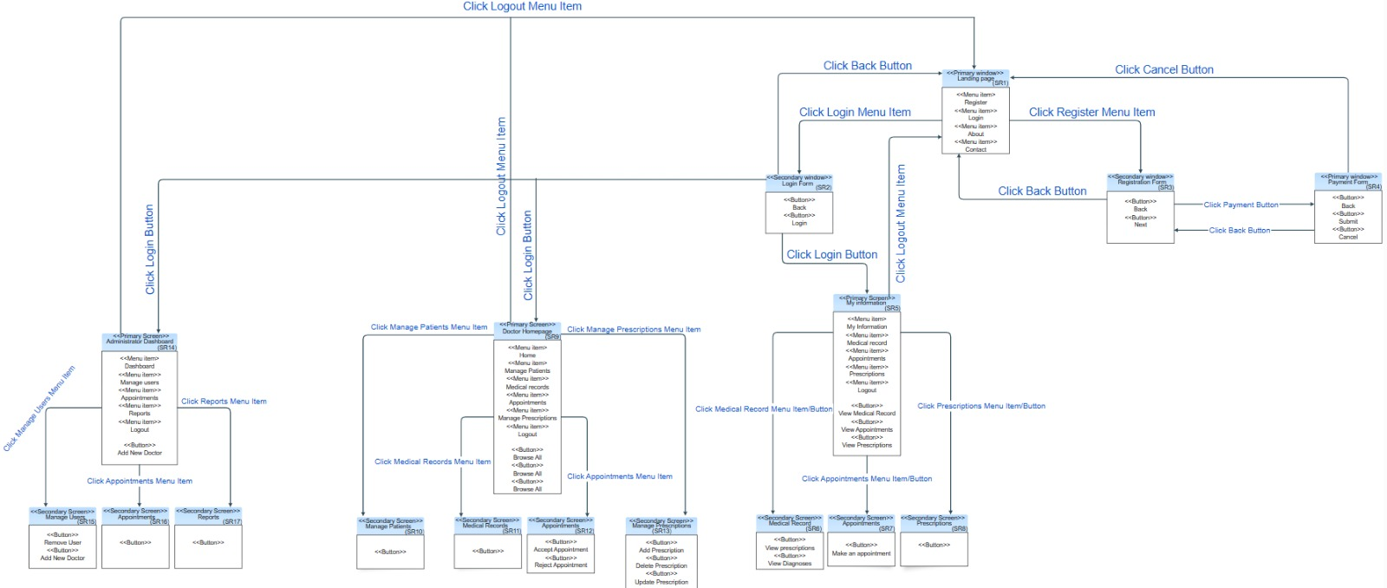

Figure 10: UML WINDOW

### WINDOW SCREEN FLOW DIAGRAM - PATIENT

*Figure 11: WINDOW SCREEN FLOW DIAGRAM*

### WINDOW SCREEN FLOW DIAGRAM - HEALTHCARE PROVIDER

### 

Figure 12: HEALTHCARE PROVIDER

#### SCREENSHOTS

### SR1: REGISTRATION PAGE

This display permits end users such as patients to register into the system. The end user initiates their journey by providing personal information, address information, and accepting terms to create an account.

CR17: Link for About

CR16: Link for login

CR15: Link for register

CR18: Link for contact

CR11: DropdownList for Province name

CR7: Radio button for gender

CR2: Textbox for Last name

CR3: Textbox for ID Number

CR4: Textbox for D.O.B

CR5: Textbox for Cellphone No

CR6: Dropdown list for title

CR1: Textbox for first name

CR8: Textbox for street name

CR9: Textbox for Suburb name

CR10: Textbox for City

CR12: Textbox for Postal code

CR13: Checkbox for Accepting T&C’S

Figure 13: REGISTRATION PAGE

# 

CR14: Button to submit.

|  |  |  |  |  |
| --- | --- | --- | --- | --- |
| Reference | | Control Type | Data Input | Data Out |
| CR1 | Textbox | | Enter the first name |  |
| CR2 | Textbox | | Enter the last name |  |
| CR3 | Textbox | | Enter ID Number |  |
| CR4 | Textbox | | Enter Date of birth |  |
| CR5 | Textbox | | Enter your cell phone number |  |
| CR6 | DropdownList | | Select title | DropdownList items |
| CR7 | Radio button | | Click gender |  |
| CR8 | Textbox | | Enter Street name |  |
| CR9 | Textbox | | Enter Suburb |  |
| CR10 | Textbox | | Enter City |  |
| CR11 | DropdownList | | Enter province | DropdownList items |
| CR12 | Textbox | | Enter postal |  |
| CR13 | Checkbox | | Click/Accept Terms & conditions |  |
| CR14 | Button | | Click |  |
| CR15 | Link | | Register |  |
| CR16 | Link | | Login |  |
| CR17 | Link | | About |  |
| CR19 | Link | | Contact |  |

Table 15: SR1: Registration page

### SR2: PAYMENT INTERFACE/ PROCESSING

After submitting registration details, this screen allows users to proceed by securing payment input their payment details to settle fees via credit card. Armed with valid payments users can log in with credentials. The user will be redirected to the login page automated by the system.

CR19: Textbox for the name on card

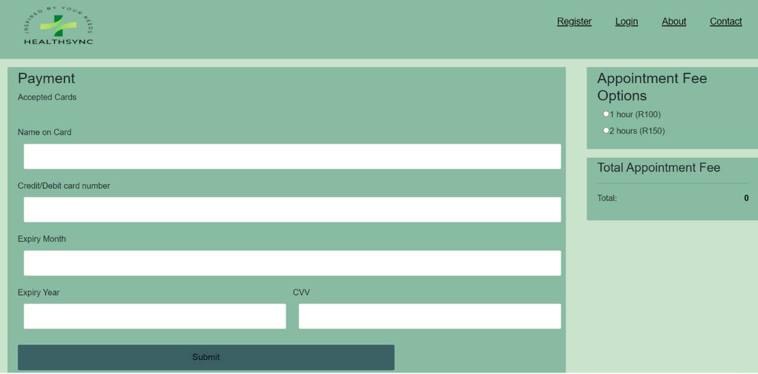

CR23: Button to checkout

CR20: Textbox Card-number

CR25: Radio button for hour

CR24: Textbox for CVV

CR21: Textbox for Exp month

CR22: Textbox for Exp year

Figure 14: PAYMENT INTERFACE/ PROCESSING

|  |  |  |  |  |
| --- | --- | --- | --- | --- |
| Reference | Control Type | Data Input | Data Out | |
| CR19 | Textbox | Enter the name on the card | |  |
| CR20 | Textbox | Enter Card-number | |  |
| CR21 | Textbox | Enter Exp month | |  |
| CR22 | Textbox | Enter Exp year | |  |
| CR23 | Button | Click | |  |
| CR24 | Textbox | Enter CVV | |  |
| CR25 | Radio button | Click gender | |  |

Table 16: SR2: PAYMENT INTERFACE/ PROCESSING

### SR3: LOGIN PAGE

Users access the system using login credentials and select their roles as “Patients” or “Healthcare providers”. Shortly after, users are authorized to log into the system and carry out with desired action, they will be directed to the relevant page according to their role in the system.

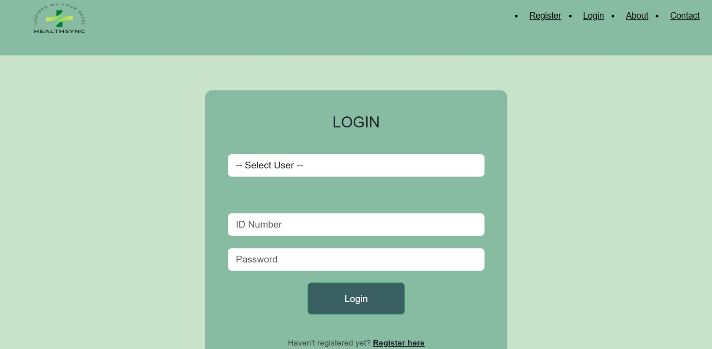

CR29: Dropdown list Select User

CR28: Button for Login

CR26: Textbox for ID Number

CR27: Textbox for Password

Figure 15: LOGIN PAGE

|  |  |  |  |
| --- | --- | --- | --- |
| Reference | Control Type | Data Input | Data Out |
| CR26 | Textbox | Enter the ID Number |  |
| CR27 | Textbox | Enter Password |  |
| CR28 | Button | Click |  |
| CR29 | Dropdown list | Select user | Dropdown list items |

Table 17: SR3: LOGIN PAGE

### SR4: PATIENT HOME PAGE FOR HEALTHCARE PROVIDERS.

Upon login, patients gain access to the home interface, empowering them to book appointments, access prescriptions, and review medicine. After completing desired tasks, patients can conveniently log out. While healthcare providers effortlessly access the system with their unique credentials. Healthcare providers are welcomed by a tailored dashboard, enabling efficient interaction with forms for appointment management, prescription handling, patient histories, and report viewing.

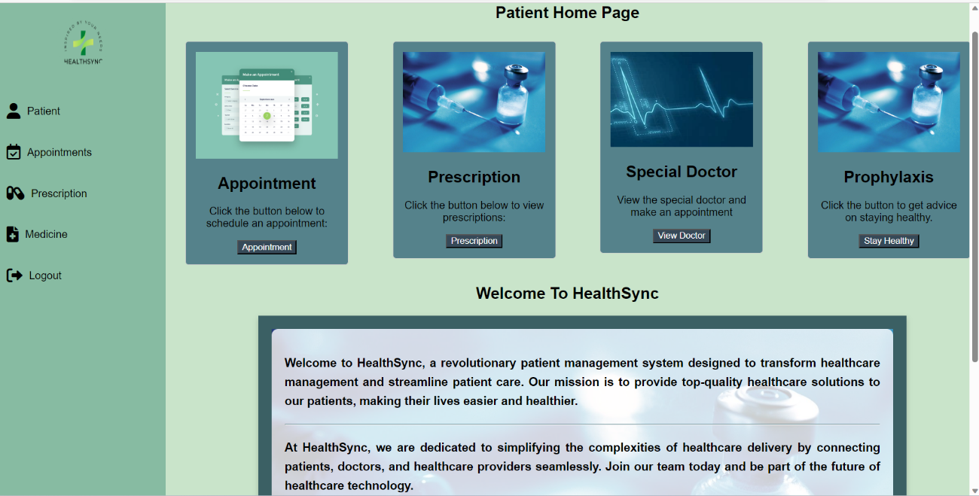

CR34: Link for logout

CR33: Link for reports

CR32: Link for Prescription

CR31: Links for Appoint

CR30: Link for Patients

CR36: Button for Prescription

CR37: Button for View doctor

CR38: Button for Medication

CR35: Button for Appointments

Figure 16: PATIENT HOME PAGE

|  |  |  |  |
| --- | --- | --- | --- |
| Reference | Control Type | Data Input | Data Out |
| CR30 | Link | Patients |  |
| CR31 | Link | Prescribe Medicine |  |
| CR32 | Link | Manage Appointment |  |
| CR33 | Link | Reports |  |
| CR34 | Link | Logout |  |
| CR35 | Button | Click |  |
| CR36 | Button | Click |  |
| CR37 | Button | Click |  |
| CR38 | Button | Click |  |

Table 18: SR4: PATIENT HOME PAGE FOR HEALTHCARE PROVIDERS

### SR5: PATIENTS MAKE AN APPOINTMENT

CR49: Link for Appointments

This screen allows patients to schedule appointments and confirm them. At the bottom is the appointment information.

CR47: Link for home page

CR50: Link for prescription

CR46: Button for appointment

CR46: Dropdown for hospital

CR44: Textbox for Cell phone number

CR45: Dropdown for Doctors name

CR40: Dropdown list Medical Department

CR39: Textbox for patient name name

CR42: Dropdown list for appointment

CR41: Textbox for symptoms

Figure 17: APPOINTMENT SCHEDULING

|  |  |  |  |
| --- | --- | --- | --- |
| Reference | Control Type | Data Input | Data Out |
| CR39 | Textbox | Enter the patient’s name |  |
| CR40 | Dropdown list | Medical | Dropdown list items |
| CR41 | Textbox | Enter Symptoms |  |
| CR42 | Dropdown list | Appointment | Dropdown list items |
| CR43 | Dropdown list | Hospital | Dropdown list items |
| CR44 | Textbox | Enter cell phone number |  |
| CR45 | Dropdown list | Doctors name | Dropdown list items |
| CR46 | Button | Click |  |
| CR47 | Link | Home page |  |
| CR48 | Link | Medical record |  |
| CR49 | Link | Appointments |  |
| CR50 | Link | Prescription |  |

Table 19: APPOINTMENT SCHEDULING

### SR6: PRESCRIPTION.

This screen is displayed after a patient has scheduled an appointment with the doctor and has been diagnosed by a healthcare provider. This screen allows patient to see prescribed medication provided by healthcare professional and their usable dosage as per doctor’s instructions.

CR51: Button to view diagnosis

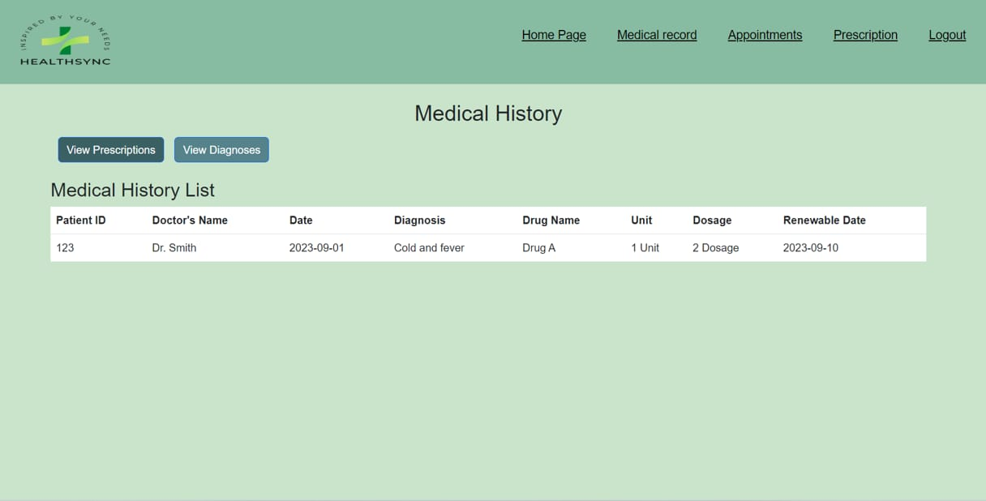

CR52: Button to view prescriptions.

Figure 18: PRESCRIBED MEDICINE

|  |  |  |  |
| --- | --- | --- | --- |
| Reference | Control Type | Data Input | Data Out |
| CR51 | Button | Click |  |
| CR52 | Button | Click |  |
|  |  |  |  |

Table 20: PRESCRIBED MEDICINE

### SR7: MEDICINE

The screen presents a summarized view of medication guidelines provided by healthcare provider.

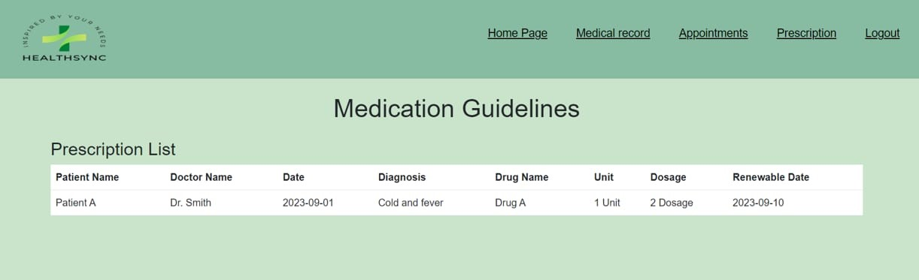

Figure 19: MEDICINE

### SR8: HOMEPAGE FOR HEALTHCARE PROVIDERS.

On this screen healthcare providers are welcomed by a tailored dashboard, enabling efficient interaction with forms for appointment management, prescription handling, patient histories, and report viewing.

CR53: hyperlink for doctors

CR56: hyperlink for reports

CR55: hyperlink for manage payment

CR54: hyperlink for manage appoint.

CR54: hyperlink for manage prescription

Figure 20: HOMEPAGE FOR HEALTHCARE PROVIDER(S).

|  |  |  |  |
| --- | --- | --- | --- |
| Reference | Control Type | Data Input | Data Out |
| CR55 | Button | Click |  |
| CR56 | button | Click |  |

Table 21: SR7: HOMEPAGE FOR HEALTHCARE PROVIDER(S).

### SR9: DOCTORS

This screen presents a tabular summary of the doctor's ID, name, specialty, and contact.

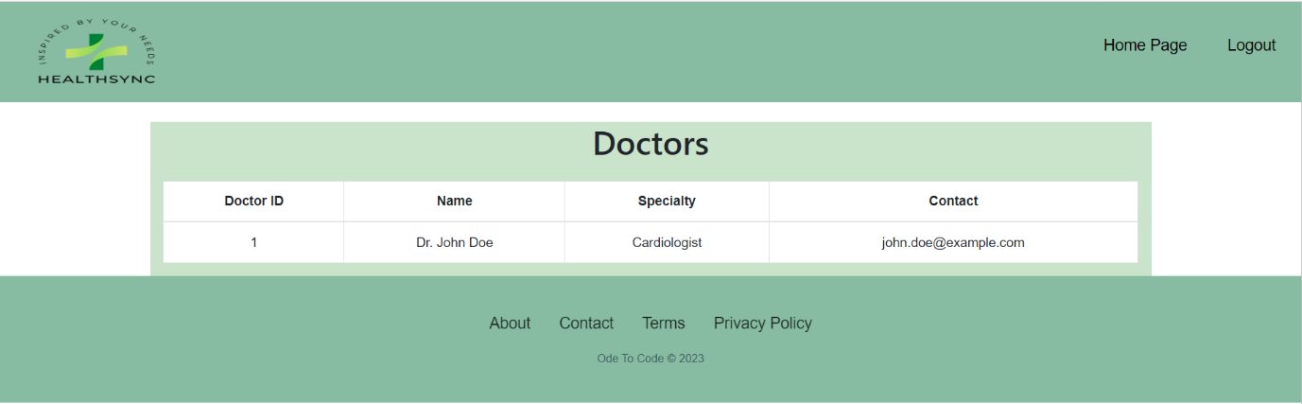

Figure 21: DOCTORS

### SR10: MANAGE PRESCRIPTION.

On the manage prescription medicine can allocate a patient's name, and diagnosis with the use of a textbox and they may write the drug name, unit, and dosage. Healthcare providers can even state the renewal, they can even add the diagnosis, delete and the update diagnosis button, and changes to the database of the system.

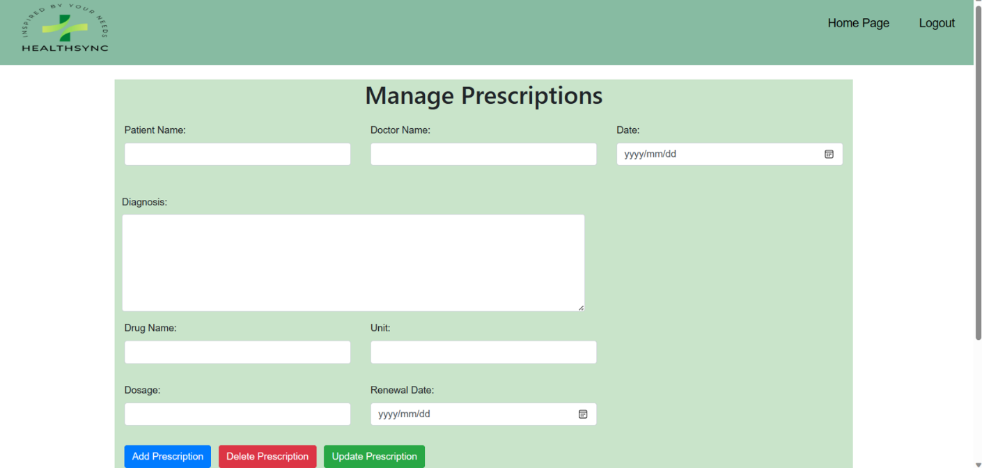

CR60: Textbox for dosage

CR65: Textbox for unit

CR67: Text for doctor’s name

CR66: Date Picker for date

CR64: Date Picker for renewal date

CR57: Textbox Patient name.

CR58: Textbox for diagnosis

CR59: Textbox for drug name.

Figure 22: PRESCRIPTION MANAGEMENT

CR63: Button to update prescription.

CR62: Button to delete prescription.

CR61: Button to add prescription.

|  |  |  |  |
| --- | --- | --- | --- |
| Reference | Control Type | Data Input | Data Out |
| CR57 | Textbox | Enter patient name |  |
| CR58 | Textbox | Enter diagnosis |  |
| CR59 | Textbox | Enter drug |  |
| CR60 | Textbox | Enter dosage |  |
| CR61 | Button | Click |  |
| CR62 | Button | Click |  |
| CR63 | Button | Click |  |
| CR64 | Date Picker | Select date | Renewal date |
| CR65 | Textbox | Enter unit |  |
| CR66 | Date Picker | Select date | date |
| CR67 | Textbox | Enter doctors name |  |

Table 22: PRESCRIPTION MANAGEMENT

### SR11: MANAGE APPOINTMENTS

This is the screen that allows healthcare providers to manage appointments to search patient ID, search patient name, and update.

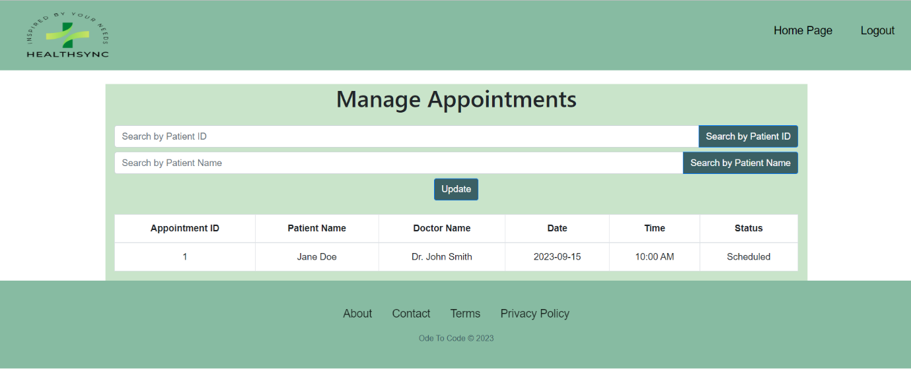Figure 23: APPOINTMENTS MANAGEMENT

CR71: Button to search patient name.

CR68: Textbox for patient ID

CR70: Button to update.

CR72: Button to search patient ID

CR69: Textbox for patient name

|  |  |  |  |
| --- | --- | --- | --- |
| Reference | Control Type | Data Input | Data Out |
| CR68 | Textbox | Enter patient ID |  |
| CR69 | Textbox | Enter patient name |  |
| CR70 | Button | Click |  |
| CR71 | Button | Click |  |
| CR72 | Button | Click |  |

Table 23: APPOINTMENTS MANAGEMENT

### SR12: MANAGE PAYMENTS

The displayed screen allows users to manage payments by searching patient ID and selecting filter by payment status.

CR74: Button to search

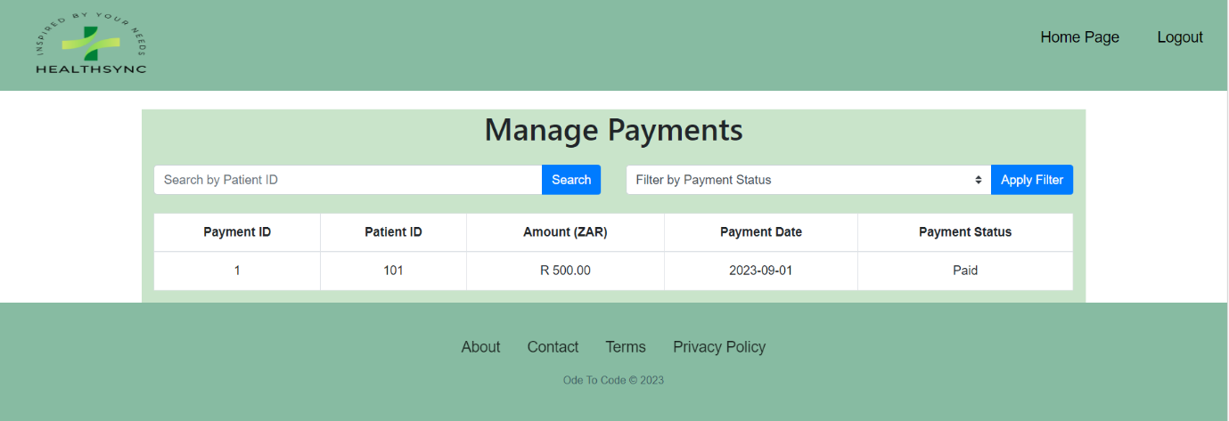

CR76: Button to Apply filter.

CR75: Dropdown list for filters

CR74: Textbox for search patient ID

Figure 24: PAYMENTS MANAGEMENT

|  |  |  |  |
| --- | --- | --- | --- |
| Reference | Control Type | Data Input | Data Out |
| CR73 | Textbox | Enter patient ID |  |
| CR74 | Button | Click |  |
| CR75 | Dropdown list | Select filter | Dropdown list items |
| CR76 | Button | Click |  |

Table 24: PAAYMENTS MANAGEMENT

### SR13: REPORTS.

On the system reports page, the system displays a summary of the total patients, doctors, and total payments.

Figure 25: REPORTS

### SR14: CONTACT US

The ‘’Contact Us’’ page is the page on the system that allows user to enter their first name, last name, and email and enables users to write their messages.

CR77: Textbox for first name

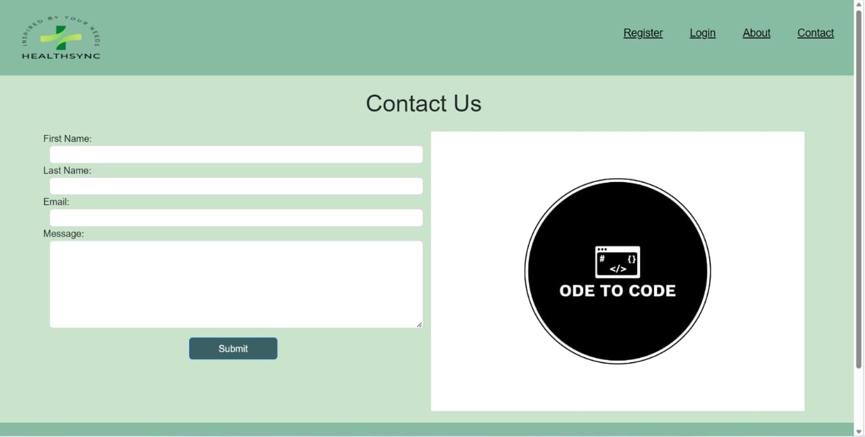

CR80: Textbox for message

CR78: Textbox for last name

CR79: Textbox for email

CR81: Button to submit

Figure 26: CONTACT PAGE

|  |  |  |  |
| --- | --- | --- | --- |
| Reference | Control Type | Data Input | Data Out |
| CR77 | Textbox | Enter first name |  |
| CR78 | Textbox | Enter last name |  |
| CR79 | Textbox | Enter email |  |
| CR80 | Textbox | Enter message |  |
| CR81 | Button | Click |  |
|  |  |  |  |

Table 25: SR15: CONTACT PAGE